DRAWING APPLICATION SYSTEM

**SYNOPSIS**

OF MAJOR PROJECT

# BACHELOR OF COMPUTER APPLICATIONS

**6th Semester (2020-2023)**

SUBMITTED BY

# DINESH SINGH

BATCH YEAR – 2020-2023 ENROLLMENT NO. – U2046035

# PROJECT GUIDE – Mr. ANAND DURGA SINGH



**Centre of Computer Education & Training Institute of Professional Studies**

# University of Allahabad, Prayagraj Uttar Pradesh

1. Introduction… 3
2. Problem Definition… 3
3. Motivation… 4
4. Objective 4
5. Requirement Analysis… 5
6. System Design… 6
7. Project Architecture 7
8. Milestone… 8
9. Meeting with the Supervisor… 9
10. Bibliography… 10

Drawing Application System is the application software used to create simple images like vector graphics on canvas using various tools like Pencil, Eraser, Brushes, colors and various shapes for example rectangle, circle, oval etc.

User can also import files like images from the local computer and use it in their Drawing project. This application also provides features to save, save as, edit, open, close files and so on.

This application provides support of large number of colors and provides features to insert text which helps user to make their drawing project more interactive and eye-catching.

# PROBLEM DEFINITION

Drawing Application helps user to draw sketches, images and pictures according to the user necessity. This application will also provide features like edit, where we can resize, change its appearance, compress the selected images or pictures.

User can register or login him/her with UserId and password which create separate workspace for them where they can save their work and made it inaccessible from the other user. User can also access their works remotely by simply login in the application.

This application is useful for a beginner for creating simple drawing as well as to create advanced designs as it has vast range of tools support.

The Graphical User Interface of this application is very interactive and user friendly which provides ease of use to the user so they can use this application without any difficulty. In this we have all important graphical icons like pencil, brush, eraser, coloring tools, text boxes and all by which user can easily use these tools to create their illustrations to fulfill their requirements.

User can also create their own personal lobby where they can hide their work from other users by creating User id and Password.

# OBJECTIVE

The main objective of this project to built a Drawing Application System using Python which provides the following features.

* Drawing tools to draw objects, for example lines, arcs, polygons etc.
* Vast amount of coloring tools to make the drawing objects more attractive.
* Facility to import other image files which can be used in the current work.
* User can have their separate workspace which made this application multiuser.
* User ID and Password make user’s files secure from unwanted access and modification.

# SOFTWARE REQUIREMENT

* **Operating System:** Window/Linux/Mac
* **Language Used :** Python
* **Database :** MySQL
* **IDE :** VsCode/Pycharm/IDLE

# HARDWARE REQUIREMENT

* **CPU:** Intel I5 Gen-10
* **RAM :** 8 GB or Higher

System Design includes the various modules of the system which will build. In other word it describes about the features that the software is going to provide and how it will be helpful to the target user/client.

# Main Window

Basic Interface with all the important tools and the canvas area for drawing the sketches.

# Login/Register

Here user can register/login him/her to create their own workspace to accomplish security and confidentiality.

**BASIC PROJECT STRUCTURE**

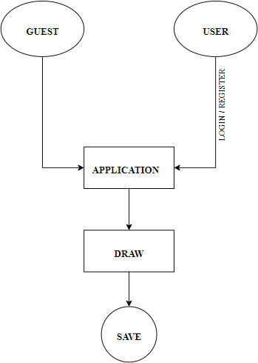

**LOGIN & REGISTRATION**

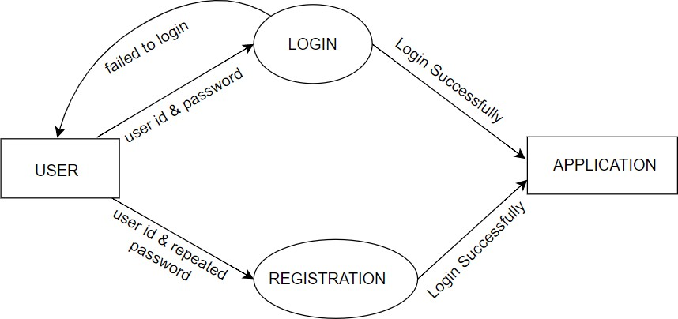

|  |  |  |  |
| --- | --- | --- | --- |
| **S.No.** | **Project Activity** | **Estimated Start Date** | **Estimated End Date** |
| 1. | Synopsis Completion | 17/02/2023 | 22/02/2023 |
|  |  |  |  |
|  |  |  |  |
|  |  |  |  |
|  |  |  |  |
|  |  |  |  |
|  |  |  |  |
|  |  |  |  |
|  |  |  |  |
|  |  |  |  |
|  |  |  |  |

|  |  |  |  |
| --- | --- | --- | --- |
| **Date of the meet** | **Mode** | **Comments by the Supervisor** | **Signature of the Supervisor** |
|  |  |  |  |
|  |  |  |  |
|  |  |  |  |
|  |  |  |  |
|  |  |  |  |
|  |  |  |  |
|  |  |  |  |
|  |  |  |  |
|  |  |  |  |

# BIBLIOGRAPHY

1. [**https://turbofuture.com/computers/Introduction-to-Ms-Paint**](https://turbofuture.com/computers/Introduction-to-Ms-Paint)
2. [**https://en.wikipedia.org/wiki/Microsoft_Paint**](https://en.wikipedia.org/wiki/Microsoft_Paint)